***Tablet Holder***

***Outcome***

***Option 4***

***Option 3***

***Option 2***

design #4

***Option 1***

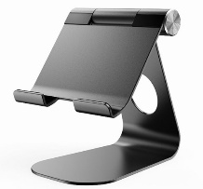

***Holder type***

**Magnatic**

**fasteners**

**fabric fasteners**

**metal fasteners**

**Glue**

**fasteners**

***typs***

***Adjustable***

***Folded***

***Fixed***

***Features***

***charger***

**The compound stand is Compatible,economical ,** **sleek shape. also Cotton is more aesthetic**.

***Linen and***

***Cotton***

***Material***

***Aluminum***

***Fabric***

***Denim***